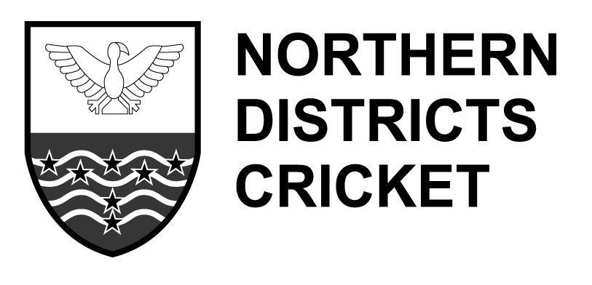
Level 2 Course 2015

I wish to enrol for the NZC Level 2 Course for 2015

Name
Address
Home Phone
Mobile Phone
Email

My qualifications/experience is as follows. (Playing experience, coaching experience, certificates already gained)

I understand that the course is limited to 12 participants and not all applicants will gain entry to the course.

I understand that the course has a fee of $100 to cover cost of resources.

Note that the course is run in modules, usually one Sunday each month June to October.

Applications close May 31.Send to pat@ndca.co.nz or to Pat Malcon, ND Cricket, POBox1347,Hamilton 3240.

