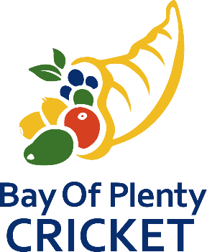

BAY OF PLENTY CRICKET ASSOCIATION APPROVED BALLS

The schedule of approved balls is as follows:
- Attrill Cup, Williams Cup, Baywide Cup, Baywide T20
Kookaburra Red (Regulation 156gm 4 Piece)
Kookaburra White (Regulation 156gm 4 Piece)

- McNaughton Trophy
Kookaburra Red (Club Match 156gm 4 Piece)

- Baywide Secondary School
Kookaburra (Red King 156gm 2 Piece)
Kookaburra (Red King 142gm 2 Piece)

